|  |  |  |
| --- | --- | --- |
| Product Catalogue | AC/DC power connector |  |
| Connector type | DC power socket |  |
| Installation method | Angled plug |  |
| Contact inner diameter | - |  |
| Contact outer diameter | - |  |
| Rated curren | 5A |  |
| Rated voltage | 20V |  |
| Operating temperature range | -25℃~+70℃ |  |

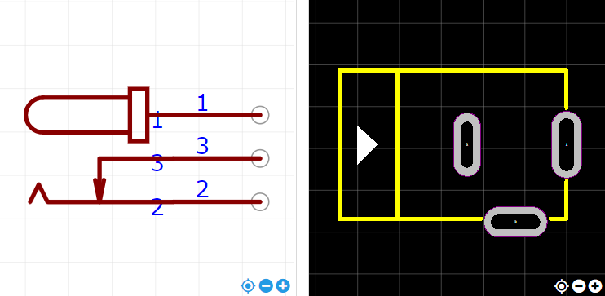

<https://item.szlcsc.com/419795.html>